Java program

Day-1
1.Hello world program
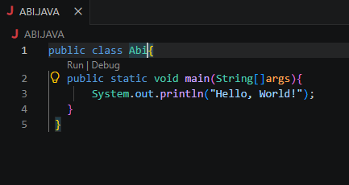

Day-2
1.driving licence
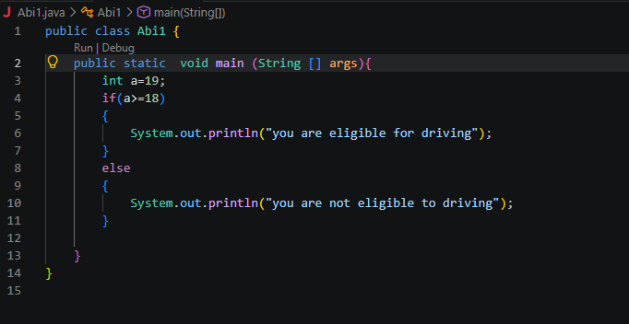
2. Even Number and Range Checker
public class Abi1 {
public static void main (String [] args){
int a=33;
if(a % 2==0 && a > 10)
{
System.out.println("the given number is even and greater than hundred");
}
else
{
System.out.println("the given number is odd and not greater than hundred");

}

}
}

3. . Student Pass Checker
public class Abi1 {
public static void main (String [] args){
int abi=50;
int att=80;
if(abi>40 && att>75)
{
System.out.println("pass");
}
else
{
System.out.println("fail");
}

}
}

4. . Shopping Discount Eligibility
public class Abi1 {
public static void main (String [] args){
int customer1=3000;
int premimum=2000;
if(customer1>=2000 || premimum<=customer1)
{
System.out.println("Discount available");
}
else
{
System.out.println(" No Discount ");
}

}
}

5. Password Length Validator

import java.util.Scanner;

public class Abi1 {
public static void main(String[] args) {
Scanner sc = new Scanner(System.in);

System.out.print("Enter password: ");
String password = sc.nextLine();

boolean isActive = true;

String result = (password.length() >= 8 && isActive)
? "Valid password"
: "Invalid password or account inactive";

System.out.println(result);

sc.close();
}
}

6. ATM Withdrawal Validation

import java.util.Scanner;

public class Abi1 {
public static void main(String[] args) {
Scanner sc = new Scanner(System.in);

System.out.print("read account balance: ");
int balance = sc.nextInt();

System.out.print("withdrawal Amount: ");
int required_Amount = sc.nextInt();

if (required_Amount % 10==0 && required_Amount <= balance)
{
System.out.println("transaction approved");
}

sc.close();
}
}

7. Login Attempt Controller
import java.util.Scanner;

public class Abi1 {
public static void main(String[] args) {
Scanner sc = new Scanner(System.in);

System.out.print("maximum attempt count: ");
int maximum=sc.nextInt();
System.out.println("current failed attempts");
int current = sc.nextInt();

if (current<maximum) {
System.out.println("allow user to login");

}
else if (current >=0)
{
current++;
}
else
{
maximum++;
}
sc.close();
}
}

Day-3
import java.util.Scanner;

public class gopi1{
public static void main(String[] args) {
Scanner sc = new Scanner(System.in);
System.out.println("PERSONAL INFORMATION");

System.out.print("Enter your name: ");
String name = sc.nextLine();

System.out.print("Enter your age: ");
int age = sc.nextInt();
sc.nextLine();

System.out.print("Enter your city: ");
String city = sc.nextLine();

System.out.println("Name: " + name);
System.out.println("Age: " + age);
System.out.println("City: " + city);

System.out.println(" TWO-NUMBER CALCULATOR");

System.out.print("Enter two integers: ");
int a = sc.nextInt();
int b = sc.nextInt();

System.out.println( a + b);
System.out.println(a - b);
System.out.println( a * b);

if (b != 0) {
System.out.println( (double) a / b);
} else {
System.out.println("Division by zero is not possible.");
}

System.out.println(" RECTANGLE CALCULATOR");

System.out.print("Enter length: ");
double length = sc.nextDouble();

System.out.print("Enter breadth: ");
double breadth = sc.nextDouble();

double area = length * breadth;
double perimeter = 2 * (length + breadth);

System.out.println( area);
System.out.println( perimeter);

System.out.println(" STUDENT MARKS");

sc.nextLine();
System.out.print("Enter student name: ");
String studentName = sc.nextLine();

System.out.print("Enter five subject marks: ");
int m1 = sc.nextInt();
int m2 = sc.nextInt();
int m3 = sc.nextInt();
int m4 = sc.nextInt();
int m5 = sc.nextInt();

int total = m1 + m2 + m3 + m4 + m5;
double average = total / 5.0;

System.out.println(studentName);
System.out.println(total);
System.out.println( average);

System.out.println(" EMPLOYEE SALARY");

sc.nextLine();
System.out.print("Enter employee name: ");
String employeeName = sc.nextLine();

System.out.print("Enter basic salary: ");
double basic = sc.nextDouble();

System.out.print("Enter bonus: ");
double bonus = sc.nextDouble();

double salary = basic + bonus;

System.out.println( employeeName);
System.out.println( salary);

System.out.println("SWAP TWO NUMBERS");

System.out.print("Enter two integers: ");
int x = sc.nextInt();
int y = sc.nextInt();

System.out.println("Before swapping:");
System.out.println("a = " + x);
System.out.println("b = " + y);

int c = x;
x = y;
y = c;

System.out.println("After swapping:");
System.out.println("a = " + x);
System.out.println("b = " + y);

sc.close();
}
}

